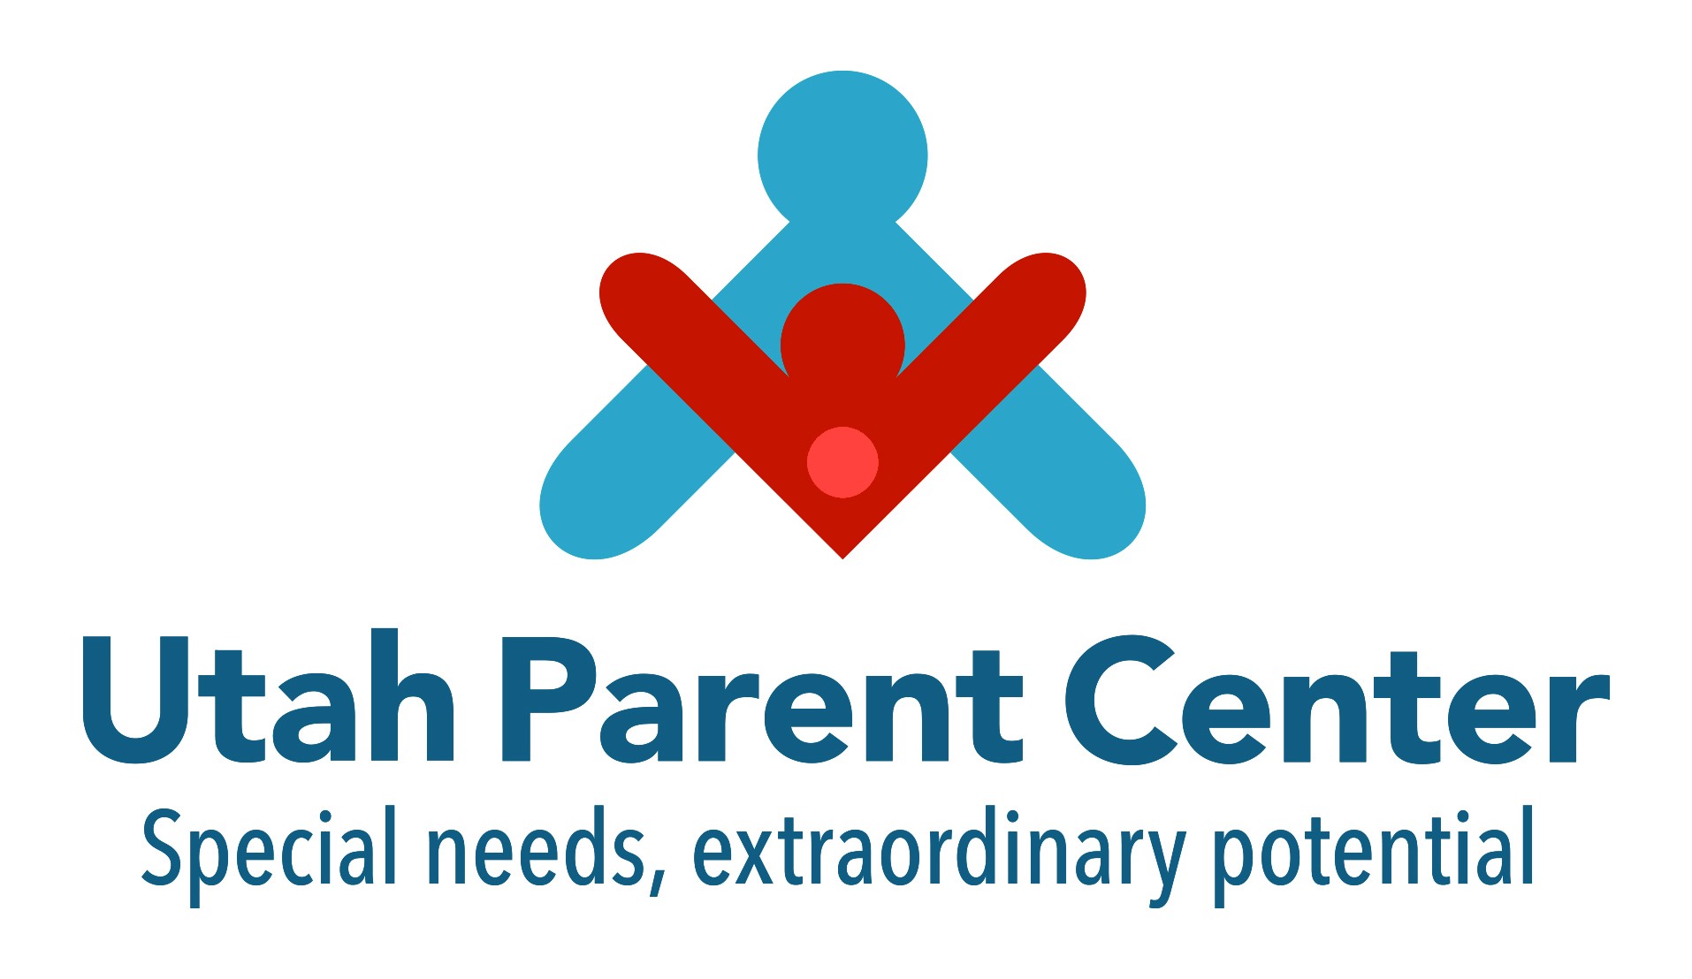

Services

Utah Parent Center
230 West 200 South
Suite 1101
Salt Lake City, UT 84101
801.272.1051
1.800.468.1160
info@utahparentcenter.org
www.utahparentcenter.org

Services for People with Disabilities
Division of Services for People with Disabilities (DSPD)
Website: https://dspd.utah.gov/
Intake: 1-887-568-0084

The Division of Services for People with Disabilities (DSPD) promotes opportunities and provides supports for people with disabilities to lead self-determined lives by overseeing home and community-based services. Support includes respite, behavior supports, supported employment, community living, and day services, and day services. A person MAY be eligible for services if they have qualifying disabilities in one of the three areas listed: Intellectual Disabilities or Related Conditions, Acquired Brain Injury or Physical Disabilities. There is a waiting list.

Medicaid
Website: https://medicaid.utah.gov/

Medicaid is a source of health care coverage for Utah’s vulnerable populations. Medicaid is a state/federal program that pays for medical services for low-income pregnant women, children, individuals who are elderly or have a disability, parents and women with breast or cervical cancer. To qualify, these individuals must meet income and other eligibility requirements.

Utah Division of Substance Abuse & Mental Health, Mental Health and Community Mental Health Centers
Website: https://dsamh.utah.gov/mental-health/

- Family Resource Facilitators (FRF) – Mental Health Advocates for Parents
Call Allies with Families, NAMI Utah for local FRF
FRF for Dual Diagnosis (Individual who has both a Disability and Mental Health) call the Utah Parent Center

- Allies with Families
Phone: (801) 433-2595
Website: http://allieswithfamilies.org/

- NAMI Utah (National Alliance for the Mentally Ill)
Phone: (801) 323-9900
Website: http://www.namiut.org/

3. Utah Parent Center (UPC)
Phone: (801) 272-1051
Website: http://utahparentcenter.org

Utah State Board of Education (USBE)
Website: http://www.schools.utah.gov/sars/
- Special Education Services
Website: http://www.schools.utah.gov/sars/
- Department of Education Equity – Section 504
Website: http://www.schools.utah.gov/equity/
Momi Tu-ua – Student Advocacy Services, 504 Specialist

Utah State Office of Rehabilitation (USOR)
Website: https://www.usor.utah.gov/

- Vocational Rehabilitation (VR)
Website: https://www.usor.utah.gov/vr
Transition: https://www.usor.utah.gov/parents-and-teachers

VR helps individuals with disabilities obtain meaningful employment, integrate into the community, improve accessibility and independence in their activities of daily living, and determine eligibility for federal disability benefits.

- Utah Center for Assistive Technology (UCAT)
Website: https://www.usor.utah.gov/ucat

The Utah Center for Assistive Technology (UCAT) is a statewide resource offering information and technical services to help people with disabilities acquire and use assistive technology devices. Our services are available to people with disabilities, parents and other family caregivers, rehabilitation counselors, independent living specialists, special educators, occupational therapists, physical therapists, allied medical professionals, and other who are concerned with and advocate for people with disabilities. UCAT offers free evaluations to anyone within the state of Utah.

United States Social Security Administration
Website: https://www.ssa.gov/

For more information and help contact Utah Family Voices at (801) 272-1068 or (801) 272-1051

